Annex 1: Break-even calculation
31.03.2026

General
The break-even logic is based on the following simplifying assumption:
- The average day-ahead price difference between Finland (FI) and Estonia (EE) represents the compensation that market participants expect from holding an LTTR.
- Underselling occurs when the auction income (auction clearing price × allocated volume) is lower than the implied compensation based on the day-ahead price difference.
Under this assumption, the break-even volume for a given auction is defined as the volume at which:
Auction clearing price = average FI–EE day-ahead price difference.
This volume represents the maximum capacity that could have been auctioned without underselling, given the observed bid curve.
To monitor underselling, TSOs have used the public data from the auctions on the Single Allocation Platform (SAP) as input for calculating the break-even volumes for the LTTRs. Joint Allocation Office (JAO) is appointed as the SAP, according to the methodology developed under Article 48 of the FCA. Historical auction data, including all submitted bids and related prices, is available on JAO’s website. The picture below provides a graphical example of the data available for the monthly auction at the FI-EE border for August 2025, showing that the auction cleared at a price of 12,23 EUR/MWh.
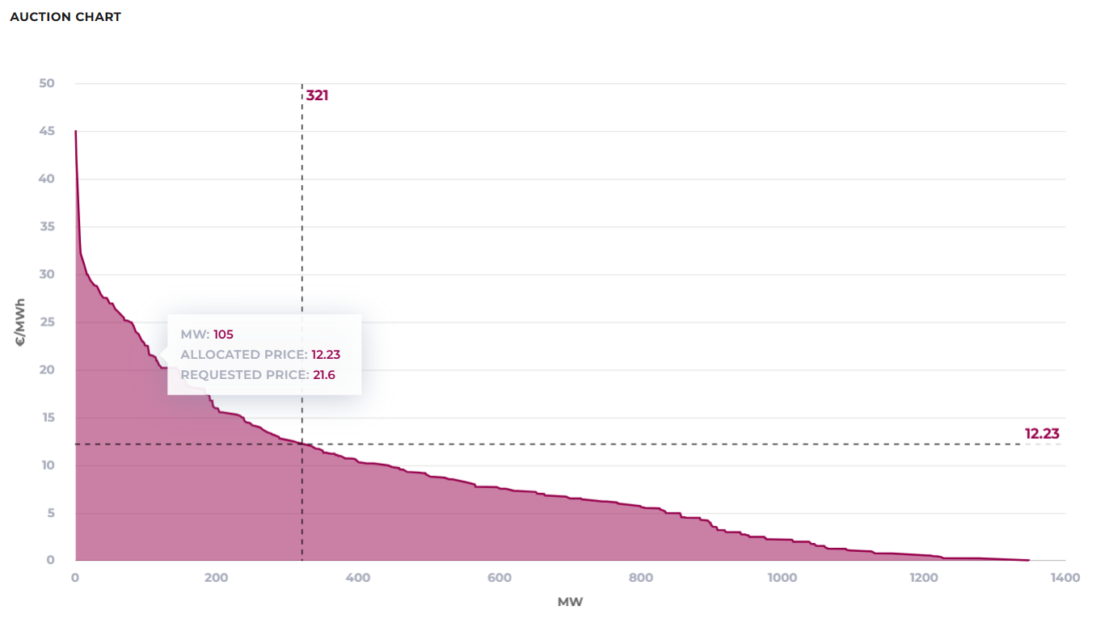

From the graph it can be investigated which volume would have prevented underselling in any given auction. The day ahead market price spread for August 2025 was 21.97 EUR/MWh, and underselling occurred during this month. The break-even volume for that month was 103 MW – indicating the volume that should have been auctioned to avoid underselling.
In some cases, the historical auction and day-ahead price data may not be considered valid to determine the breakeven volume. For example, in 2024 and 2025, the Estlink 2 connection incidents resulted in several months outage. These outages reduced the physical transmission capacity between FI-EE bidding zones to only 358 MW, instead of the normal capacity of 1 016 MW. This significant decrease led to the yearly FTR being undersold, since the market fundaments during the auctioning for the yearly product were not fulfilled for most of the year. In addition, the TSOs were able to offer only significantly reduced capacities for monthly auctions during the outage, which means that none of the auctions held during this period can be considered valid for calculating the breakeven volume, as the auctioned capacity was significantly lower than normally.

Yearly auctions
The TSOs have performed a break-even volume analysis for the LTTRs issued on the FI-EE bidding zone border. Table 1 summarizes the break-even analysis for the yearly FI–EE auctions
Table 1: Yearly break-even calculation results
Year | FI-EE Yearly Offered Capacity | FI-EE Yearly Capacity with no Oversupply | Difference
2023 | 350 | 58 | 292
2024* | 350 | 85 | 265
2025* | 350 | 56 | 294
*Estlink 2 outage
The results indicate that, under the break-even assumption, the historical yearly auctions would have required substantially lower volumes to avoid underselling.

Monthly auctions
A similar analysis has been carried out for the monthly FI–EE auctions. For each month, the break-even volume is derived from the intersection of the monthly auction bid curve and the corresponding day-ahead price difference
Table 2: Monthly break-even calculation results for 2023
Year | Month | FI-EE Monthly Offered Capacity | FI-EE Monthly Capacity with no Oversupply | Difference
2023 | 1 | 319 | 89 | 230
2023 | 2 | 319 | 1 | 318
2023 | 3 | 319 | 702 | -383
2023 | 4 | 319 | 1191 | -872
2023 | 5 | 319 | 0 | 319
2023 | 6 | 300 | 20 | 280
2023 | 7 | 300 | 8 | 292
2023 | 8 | 369 | 224 | 145
2023 | 9 | 359 | 0 | 359
2023 | 10 | 300 | 114 | 186
2023 | 11 | 300 | 566 | -266
2023 | 12 | 300 | 1347 | -1047

Table 3: Monthly break-even calculation results for 2024
Year | Month | FI-EE Monthly Offered Capacity | FI-EE Monthly Capacity with no Oversupply | Difference
2024 | 1 | 300 | 209 | 91
2024 | 2 | 300 | 48 | 252
2024* | 3 | 8 | 98 | -90
2024* | 4 | 8 | 60 | -52
2024* | 5 | 13 | 1 | 12
2024* | 6 | 8 | 0 | 8
2024* | 7 | 8 | 0 | 8
2024* | 8 | 8 | 0 | 8
2024 | 9 | 302 | 375 | -73
2024 | 10 | 300 | 12 | 288
2024 | 11 | 300 | 141 | 159
2024 | 12 | 300 | 7 | 293
*Estlink 2 outage

Table 4: Monthly break-even calculation results for 2025
Year | Month | FI-EE Monthly Offered Capacity | FI-EE Monthly Capacity with no Oversupply | Difference
2025 | 1 | 322 | 12 | 310
2025* | 2 | 29 | 0 | 29
2025* | 3 | 11 | 23 | -12
2025* | 4 | 31 | 112 | -81
2025* | 5 | 49 | 68 | -19
2025* | 6 | 49 | 307 | -258
2025 | 7 | 343 | 862 | -519
2025 | 8 | 321 | 103 | 218
2025 | 9 | 320 | 1 | 319
2025 | 10 | 310 | 36 | 274
2025 | 11 | 320 | 2 | 318
2025 | 12 | 320 | 52 | 268
*Estlink 2 outage

The tables show significant month-to-month variation. In a majority of months, the break-even capacity is clearly below the volume that was actually offered, indicating recurring underselling under the simplifying assumptions used.

Conclusions
The analysis highlights that:
- For yearly auctions, historical break-even volumes are well below the currently offered capacity. However, TSOs recognize the importance of ensuring sufficient yearly hedging opportunities, as emphasized by market participants in the course of public consultation and moreover, Baltic market participants historically higher active successful participation on yearly product auctions.
- For monthly auctions, the break-even volume varies substantially across months, but in approximately two thirds of the observed months the results indicate oversupply.
- The analysis is used as supporting evidence that the current capacity split can lead to systematic underselling, thereby motivating the proposed update to the splitting methodology. However, the TSOs do not propose to mechanically align auction volumes with the break-even results. Instead, the TSOs propose that a cap of maximum offered capacity of FI-EE FTRs is set at 350 MW, corresponding to the capacity of Estlink 1, even if the break-even volume analysis would suggest a lower value.

