13 July, 2017

Dear Madams and Sirs,

The Guideline on Electricity Balancing (GLEB), approved by EU member states on March 16th 2017, defines relevant tasks and a timeline for the implementation of an European platform for the exchange of balancing energy from frequency restoration reserves with manual activation (mFRR).

Given the importance of an efficient balancing mechanism for an integrated electricity market, 19 TSOs signed a Memorandum of Understanding on April 5th 2017, which outlines the major cornerstones of the cooperation. Shortly after, the project has been officially named MARI (Manually Activated Reserves Initiative). MARI strives to consider all TSOs tasks and timeline under the scope of the GLEB provisions concerning mFRR and aims to create the mFRR platform, which fulfills all respective provisions of the GLEB.

The MARI parties view the communication with stakeholders and their feedback as essential for achieving the project goal – the development of an user-friendly and liquid platform. As a result, we aim to establish communication with stakeholders already at a very early stage of the project via a stakeholder workshop. This workshop would provide a comprehensive picture about the MARI project, so that stakeholders gain a good understanding about the features of the platform under development.

Consequently, we would like to invite you to this

**workshop, which will be held on 4 September 2017 at the ENTSO-E premises in Brussels.**

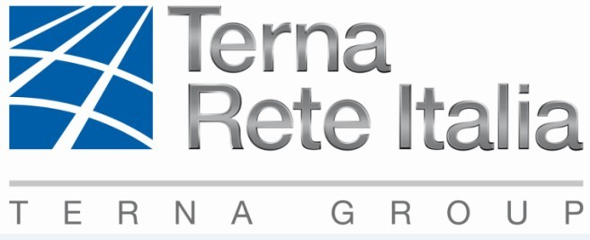

Since the number of participants is limited, we would like to stress that we accept only participation **of 1 person per 1 company.**

Those who will not be able to join the meeting can also follow us through webcast (a link will be provided to registered participants). However it has to be mentioned that you will NOT be able to make comments or ask questions during the meeting, when connected by the webcast.

Please send **your registration to Lenka Linke at** [**Lenka.linke@cz.ey.com**](mailto:Lenka.linke@cz.ey.com)as soon as possible **by 18 August 2017** at the latest and indicate:

*Subject: MARI Stakeholders Workshop*

*Your name and company*

*Your preference for participation: a) webcast; b) physical presence*

We are glad to having the chance to receive you feedback on our work and looking forward to a fruitful discussion.

Yours sincerely

Martin Høgh Møller

MARI Steering Committee Chairman